SPARTA FIFA 20 PS4 TOURNAMENT
21st to 25th September 2020*
ENTRY FORM

To enter the tournament, we just need a few details:

Your name:

Your PS4 profile name:

Your contact email to be shared with your opponent:

By entering you are agreeing to play fairly and within the few rules set by the organisers.
Please be courteous to your opponents at all times

Once completed please send this form via email to SPARTA@dft.gov.uk

To find your PS4 profile name then in the main menu go across to where it says profile and your name along with your profile name will be displayed as below. My profile name is jasondm65
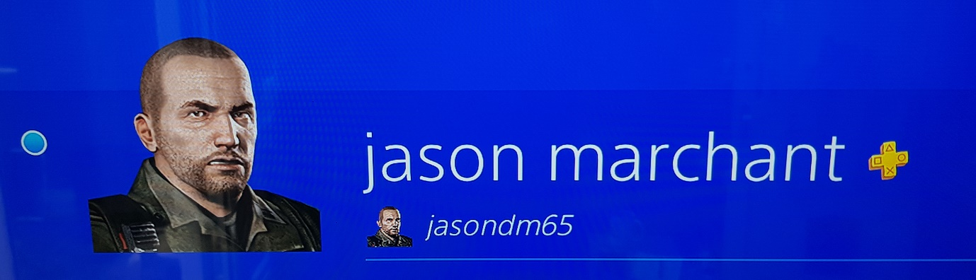
If you end up playing against me then please don’t give me a thrashing

