SPARTA -
ALL AGES HOME PENTATHLON
How to enter
The SPARTA All Ages Home Pentathlon is the simple way to have some fun competition for the whole family against your departmental colleagues and also to get embarrassed as your G7’s 6 year old daughter does a longer standing jump than you.
The whole competition is based on the Sportshall home pentathlon. It’s open to all DfT and MHCLG and agency staff, SPARTA members and their families
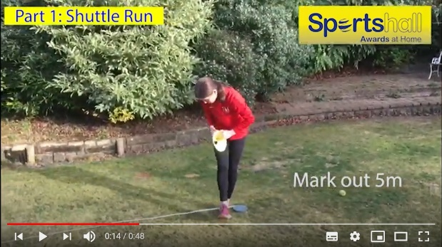
There are five very easy events. They are:
- The 5-metre Shuttle Run
- The Standing Long Jump
- The Vertical Jump
- The Speed Bounce
- The Target Throw
There are videos of the events here:
https://www.youtube.com/watch?v=o0PH0Z88SMs&list=PL6DK6xTdLkmwBkVBUkZZ2L_oTT6VXErNO&index=2&t=0s
The tournament will run over the course of the week of 22nd to 25th September 2020.
Once you have watched the videos, set up and do your home pentathlon in whatever location suits you. Your results need to be put into the spreadsheet that can be found on the SPARTA website here:
https://www.spartarecreation.co.uk/vaw-home-pentathlon
Once you have entered all your results save the results sheet and then send a copy to SPARTA@dft.gov.uk Please title your email “SPARTA HOME PENTATHLON”
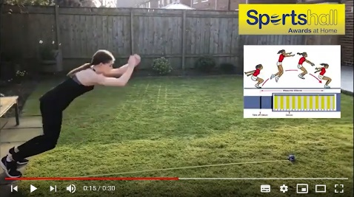
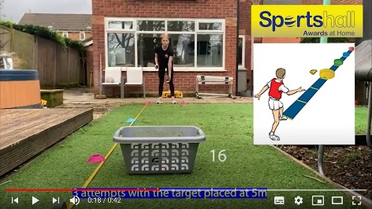
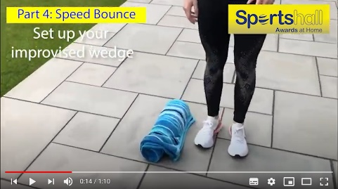
We will collate all the results and publish them to all participants so that you can compare how you have done against everyone else. If you need any further information, then please get in touch with us at SPARTA@dft.gov.uk.
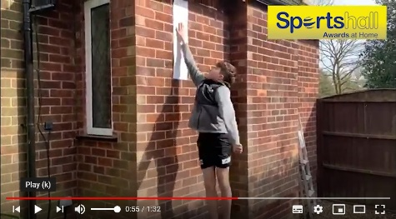
GOOD LUCK EVERYONE

Parents should ensure that if they enter their family members they are properly supervised (especially grandparents (they cheat))

